ProResume Optimizer – Resume Evaluation and Improvement System
Rishwanth Nukala
COMP-699-D Professional Seminar
Spring 2026

Executive Summary
ProResume Optimizer is a resume evaluation and improvement system designed to analyze resume content using structured, rule-based logic and provide actionable feedback. In current hiring processes, resumes function as the primary screening mechanism, often determining whether a candidate progresses to further stages. Many applicants are filtered out not because of missing qualifications, but due to unclear presentation of skills, absence of measurable achievements, weak alignment with the intended job role, or incompatibility with Applicant Tracking Systems (ATS) (Doyle, 2020; Herbert, 2024).
The system is designed as an evaluation and learning tool rather than a resume rewriting service. It assesses resumes based on predefined criteria such as structural completeness, role-specific alignment, keyword relevance, and ATS compatibility. A target job role must be selected before evaluation, ensuring that the analysis remains context-specific and aligned with expected skills and responsibilities.
The system follows a modular, object-oriented architecture in which a central controller coordinates multiple analyzer components. These include structure analysis, role alignment evaluation, and ATS compatibility assessment. Each analyzer applies rule-based logic to evaluate a specific aspect of the resume. The results are then aggregated through a scoring engine to generate category-level scores and an overall resume quality score. A structured evaluation report is produced with categorized feedback and improvement suggestions.
The system emphasizes interpretability by clearly linking evaluation outcomes to specific aspects of resume content. Instead of producing revised resumes, it identifies gaps and provides guidance that supports iterative improvement. Resume data is processed during evaluation without permanent storage, addressing privacy considerations while maintaining system functionality.
The design and implementation reflect standard principles of systems analysis and design, including modular architecture, rule-based processing, and alignment between requirements, UML models, and system behavior (Dennis et al., 2020).

Table of Contents
1. ProResume Optimizer – Resume Evaluation and Improvement System 1
2. Executive Summary 2
4. Introduction 6
4.1 Background 6
4.2 Problem Description 6
5. System Proposal 8
5.1 System Request 8
5.2 Requirements Definition 12
5.3 Functional Requirements 12
5.4 Non-Functional Requirements 14
6. Functional Model 15
6.1 Use-Case Diagram 15
6.2 Use-Case Description 17
6.3 Activity Diagram 27
7. Structural Model 31
7.1 Class Diagram 31
7.2 Object Diagram 33
8. Behavioral Model 36
8.1 Sequence Diagram 36
9. Design Model 39
9.1 Package Diagram 39
9.2 Contract (Operation Specification) 41
9.3 Method Specification 41
10. Data Management Layer Design 42
10.1 Object Persistence Format 42
10.2 Database Schema 43
11. Human–Computer Interaction Layer Design 46
11.1 Wireframe Design 46
12. Physical Architecture Layer Design 49
12.1 Hardware and Software Specification 49
12.2 Operational Requirements 49
12.3 Performance Requirements 50
13. Construction 51
13.1 Unit Test Description 51
13.2 Integration Test 52
14. Build and Run Instructions 54
15. Acknowledgements 55
16. Conclusions 56
17. References 57
18. Source Code with Unit Tests 58
18.1 Core System Implementation 58
18.2 Unit Tests 62
19. Generated Code Documentation 64
20. Class to Code Mapping 66
21. User Requirements to Code Mapping 67
21.1 Unimplemented User Requirement Explanations 68

Introduction

Background
In most job application processes, the resume serves as the first point of evaluation between a candidate and a potential employer. Before interviews are scheduled or skills are assessed in detail, resumes are reviewed to determine whether an applicant appears suitable for a given role. Because of this initial screening stage, the structure, clarity, and relevance of a resume directly influence whether an application progresses further. Resumes function as structured documents through which candidates communicate qualifications, experience, and achievements in a concise and organized manner (Doyle, 2020).
In recent years, the evaluation process has become more complex due to the increased use of Applicant Tracking Systems (ATS). These systems automatically filter resumes based on predefined criteria such as keyword relevance, formatting, and content structure. As a result, resumes must satisfy both human expectations and automated system requirements to be considered for further review (Herbert, 2024).
Within this context, resume preparation is no longer limited to listing qualifications. It requires careful alignment with job roles, clear presentation of measurable achievements, and appropriate use of role-specific terminology. Information systems that evaluate structured inputs and generate feedback can support users in understanding how their resumes perform under these conditions (Dennis et al., 2020).

Problem Description
A common issue observed among students and early career professionals is repeated job application without meaningful improvement in outcomes. In many cases, the limitation is not the absence of skills but the way those skills are presented in the resume. Resumes may lack clearly defined sections, omit measurable achievements, include vague descriptions, or fail to align with the expectations of the target job role.
The use of Applicant Tracking Systems further complicates this problem. Resumes that do not include relevant keywords or that are not structured in a system-readable format may be filtered out before reaching a recruiter. Because this filtering process is automated, candidates often do not receive feedback explaining why their applications were unsuccessful (Herbert, 2024).
Existing resume services typically focus on rewriting or redesigning resumes. While these approaches may improve presentation, they do not provide insight into the weaknesses of the original document. As a result, users may rely on external services without developing an understanding of how to construct effective resumes independently.
There is a need for a system that evaluates resumes using structured criteria and provides clear, role-specific feedback. Such a system should identify structural gaps, assess content quality, measure alignment with job requirements, and evaluate compatibility with automated screening systems. By presenting these insights in a structured and interpretable format, users can make targeted improvements and better understand how resume content affects hiring outcomes (Dennis et al., 2020).

System Proposal
The System Proposal section defines the purpose and scope of the proposed system by outlining the business need, expected functionality, and constraints that influence its design and implementation. It provides a structured description of how the system addresses the identified problem and what value it delivers to users.

System Request
The System Request formalizes the proposed system by identifying its objectives, inputs, processing requirements, outputs, and expected benefits. It serves as a high-level definition of what the system is intended to achieve and how it will operate within the problem context.
System Request: | ProResume Optimizer – Resume Evaluation and Improvement System
Project Sponsor: | Rishwanth Nukala
Business Need: | In many job search situations, the resume functions as the primary document used to evaluate candidates before further consideration. A significant number of applicants submit multiple applications without observing improvement in outcomes, often without a clear understanding of the underlying issue. In many cases, the limitation is not the absence of skills, but the way those skills are presented, structured, and aligned with the target job role.  Resumes may lack measurable achievements, contain vague descriptions, or fail to reflect role-specific expectations. In addition, the widespread use of Applicant Tracking Systems (ATS) introduces automated filtering based on keyword relevance and formatting. Resumes that do not meet these criteria may be rejected before reaching a recruiter (Herbert, 2024).  Existing resume services typically focus on rewriting or redesigning resumes. While these approaches may improve presentation, they do not provide insight into the weaknesses of the original document. This limits the user’s ability to improve resume construction independently and often leads to continued reliance on external services.  The proposed system addresses this need by evaluating resumes using structured, rule-based logic and generating feedback that identifies specific areas for improvement. The system supports users in understanding how resume content, structure, and role alignment influence evaluation outcomes (Dennis et al., 2020).
Business Requirements: | The system requirements are organized into input, processing, output, and interface components to clearly define how the system operates.  Input  - User uploads a resume file or pastes resume text  - Mandatory selection of target job role before analysis  Processing  - Resume evaluation using predefined scoring and analysis rules  - Extraction and validation of resume sections  - Detection of missing sections and measurable achievements  - Identification of weak phrasing and passive language  - Matching resume content with role-specific keywords  - Evaluation of ATS compatibility and keyword density  Output  - Resume quality score  - Structured improvement report  - Categorized feedback (Structure, Content, ATS, Role Fit)  - Highlighted suggestions within resume content  Interface  - Simple and responsive user interaction  - Resume preview with highlighted feedback  - Categorized panels for improvement recommendations  - Immediate display of evaluation results
Business Value: | The system provides both immediate and long-term value by supporting users in improving resume quality and understanding evaluation criteria.  Immediate Value  - Identifies weaknesses in resumes before submission  - Improves likelihood of passing automated ATS screening  Long-Term Value  - Supports independent resume improvement  - Reduces dependence on external resume rewriting services  - Enhances understanding of role-specific expectations and resume structure
Special Issues or Constraints: | Several constraints influence the design and implementation of the system:  - Resume evaluation depends on clearly defined rule logic and validation criteria  - Feedback provides guidance but does not guarantee job placement  - Resume data must be processed securely without permanent storage  - System interaction must remain simple and interpretable  - Evaluation rules must remain manageable to preserve usability  - System scope must align with project timeline and implementation feasibility

Requirements Definition
The Requirements Definition section specifies the functional and non-functional requirements of the ProResume Optimizer system. These requirements define the system’s expected behavior, processing capabilities, and operational constraints. Functional requirements describe the core evaluation and feedback processes, while non-functional requirements establish performance, security, usability, and design expectations that guide system implementation (Dennis et al., 2020).

Functional Requirements
The functional requirements define the operations the system must perform to support resume evaluation, scoring, and feedback generation. These requirements are derived from user interactions, system processing logic, and administrative configuration capabilities.
- A User uploads a resume file.
- A User pastes resume text into the system.
- A User selects a mandatory target job role before analysis.
- The system validates resume format and content availability.
- The system extracts textual data for evaluation.
- The system verifies presence of required resume sections.
- The system evaluates completeness of each section.
- The system identifies missing sections.
- The system detects absence of measurable achievements within experience entries.
- The system identifies weak phrasing and passive constructions.
- The system retrieves keyword library associated with selected job role.
- The system compares resume content with role-specific keywords.
- The system calculates role alignment score.
- The system identifies missing critical skills relevant to the selected role.
- The system evaluates formatting consistency.
- The system checks keyword density relative to role requirements.
- The system identifies potential ATS filtering risks.
- The system generates ATS compatibility feedback.
- The system computes weighted score for structural quality.
- The system computes weighted score for role alignment.
- The system computes weighted score for ATS compatibility.
- The system calculates overall resume quality score.
- The system generates structured improvement report.
- The system highlights improvement suggestions within resume preview.
- The system categorizes recommendations into defined panels (Structure, Content, ATS, Role Fit).
- A User re-submits modified resume for re-evaluation.
- The system re-runs analysis upon resubmission.
- An Administrator defines scoring weights for evaluation categories.
- An Administrator defines role-specific keyword libraries.
- An Administrator defines measurable achievement detection rules.
- An Administrator defines section validation criteria.
- The system stores updated rule parameters.
- The system applies updated rules in subsequent evaluations.

Non-Functional Requirements
The non-functional requirements define the quality attributes and operational constraints of the system. These requirements ensure that the system remains secure, efficient, usable, and aligned with its intended purpose.
- The system will process resume data securely.
- The system will not permanently store uploaded resume content.
- The system will restrict rule configuration access to Administrator accounts.
- The system will complete resume analysis within acceptable interactive processing time.
- The system will display evaluation results immediately after analysis completion.
- The system will present categorized feedback in a structured and readable format.
- The system will maintain a simple and intuitive interaction flow.
- The system will ensure that scoring logic remains interpretable to users.
- The system will be implemented entirely in Python.
- The system will require mandatory job role selection before evaluation.
- The system will function as a decision-support and educational tool rather than a guarantee of job placement.
- The scope of evaluation logic will remain achievable within the defined project timeline.

Functional Model
The Functional Model describes how users interact with the system and how the system processes those interactions to produce results. It focuses on external behavior, capturing system functionality through use cases and workflows. This model helps in understanding the sequence of operations and the responsibilities of the system in response to user inputs (Dennis et al., 2020).

Use-Case Diagram
The use-case diagram provides a visual representation of how external actors interact with the ProResume Optimizer system. It defines the system boundary, identifies actors, and shows the relationships between primary and supporting use cases.
In this system, two actors are represented: the User and the Administrator. The User interacts with the system to perform core actions such as selecting a target job role, uploading or pasting resume content, and re-submitting a modified resume. These actions are directly connected to the central use case, Analyze Resume, which represents the core processing functionality of the system.
The diagram shows that multiple user actions either include or extend the Analyze Resume process. For example, uploading or pasting a resume includes the analysis process, while re-submitting a resume extends it by allowing iterative evaluation. The Select Target Job Role use case is also connected to the analysis process, ensuring that evaluation is always context-specific.

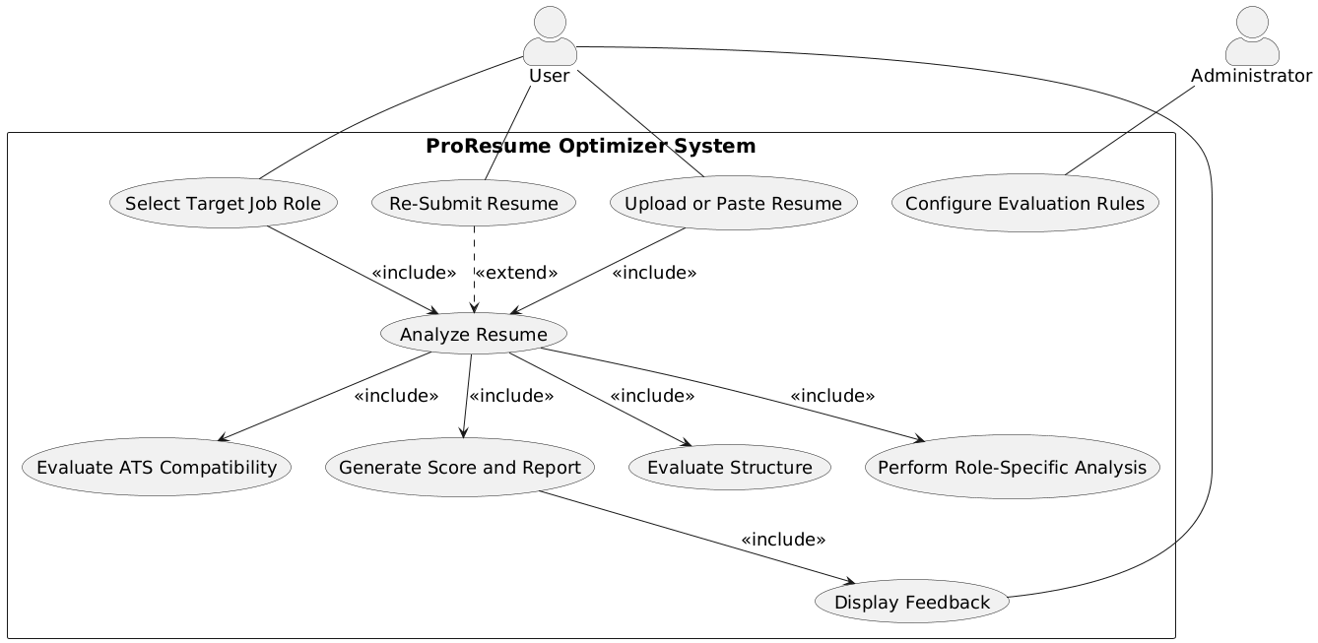
Figure 1. Use-Case Diagram – ProResume Optimizer System
The central use case, Analyze Resume, further includes several internal system processes. These include:
- Evaluate Structure, which verifies section completeness and detects missing elements
- Perform Role-Specific Analysis, which compares resume content with role-specific keywords
- Evaluate ATS Compatibility, which checks keyword density and filtering risks
- Generate Score and Report, which computes evaluation scores and prepares structured feedback
The Generate Score and Report use case is connected to Display Feedback, which represents the final step where results are presented to the user in a structured format.
The Administrator interacts with the system through the Configure Evaluation Rules use case. This use case is independent of the main evaluation flow and allows modification of scoring logic, keyword libraries, and validation criteria used during resume analysis.
The diagram clearly separates user-driven actions, system processing, and administrative configuration, while showing how all core functionalities are centered around the Analyze Resume process.

Use-Case Description
Use-case descriptions provide a detailed, step-by-step representation of how the system performs specific functions. They define interactions between actors and the system, including normal flows, validation steps, and exception handling. These descriptions ensure that system behavior is clearly specified and aligned with functional requirements.

Use Case Name: Select Target Job Role |  | ID: UC-1 | Importance Level: High
Primary Actor: User | Use Case Type: External
Related Functional Requirements: 3, 11
Stakeholders and Interests:
User requires role-specific evaluation to receive meaningful resume feedback.
The system requires a selected job role before performing analysis.
Brief Description: The User selects a mandatory target job role prior to resume analysis to enable role-specific evaluation logic.
Trigger: The User selects a job role from the available list.
Type: External
Relationships:
Association: User
Include: None
Extend: None
Generalization: None
Normal Flow of Events:
- The User accesses the job role selection interface.
- The system displays available job roles.
- The User selects a target job role.
- The system stores the selected role for the evaluation session.
- The system enables resume submission functionality.
SubFlows:
- Validate Role Selection
  - The system verifies that a role has been selected before analysis proceeds.
Alternate/Exceptional Flows:
A-1: No Role Selected
            - If no role is selected, the system prevents analysis.
            - The system displays a message requiring role selection.

Use Case Name: Upload or Paste Resume |  | ID: UC-2 | Importance Level: High
Primary Actor: User | Use Case Type: External
Related Functional Requirements: 1, 2, 4, 5
Stakeholders and Interests:
User requires the ability to submit resume content for evaluation.
The system requires accessible resume content for analysis processing.

Brief Description: The User uploads a resume file or pastes resume text into the system for evaluation.
Trigger: The User selects the upload or paste resume option.
Type: External
Relationships:
Association: User
Include: Analyze Resume (UC-4)
Extend: None
Generalization: None
Normal Flow of Events:
- The User selects the upload or paste option.
- The system prompts the User to upload a file or paste resume text.
- The User submits resume content.
- The system validates resume format and content availability.
- The system extracts textual data for evaluation.
- The system confirms successful submission.
- The system initiates resume analysis.
SubFlows:
- Validate Resume Content
  - The system checks that resume content is not empty.
  - The system verifies supported file format if a file is uploaded.
Alternate/Exceptional Flows:
A-1: Invalid Format or Empty Content
            - If resume content is invalid or empty, the system displays an error message.
            - The system requests resubmission.

Use Case Name: Re-Submit Resume |  | ID: UC-3 | Importance Level: Medium
Primary Actor: User | Use Case Type: External
Related Functional Requirements: 26, 27
Stakeholders and Interests:
User expects the ability to improve and re-evaluate the resume after receiving feedback.
The system must re-run evaluation using the updated resume content.

Brief Description: The User submits a modified resume for re-evaluation after reviewing prior feedback.
Trigger: The User selects the re-submit option after making modifications.
Type: External
Relationships:
Association: User
Include: Analyze Resume (UC-4)
Extend: None
Generalization: None
Normal Flow of Events:
- The User selects the re-submit option.
- The system prompts the User to upload or paste the updated resume.
- The User submits the modified resume content.
- The system validates the updated content.
- The system initiates resume analysis.
SubFlows:
- Validate Modified Resume
  - The system checks that updated content is not empty.
  - The system verifies acceptable format if a file is uploaded.
Alternate/Exceptional Flows:
A-1: Invalid or Empty Submission
            - If the updated resume is invalid or empty, the system displays an error message.
            - The system prevents re-analysis until valid content is provided.

Use Case Name: Analyze Resume |  | ID: UC-4 | Importance Level: High
Primary Actor: System | Use Case Type: Internal
Related Functional Requirements: 6–10, 15
Stakeholders and Interests:
User expects objective structural evaluation of resume content.
The system requires structured analysis to detect completeness, phrasing quality, and formatting consistency.
Brief Description: The system analyzes resume content to evaluate structural completeness, measurable achievements, phrasing strength, and formatting consistency.
Trigger: Invocation after resume submission or resubmission.
Type: Internal
Relationships:
Association: None
Include: Evaluate Structure (UC-7)
Extend: None
Generalization: None
Normal Flow of Events:
- The system receives extracted resume text.
- The system verifies presence of required resume sections.
- The system evaluates completeness of each section.
- The system identifies missing sections.
- The system detects absence of measurable achievements in experience entries.
- The system identifies weak phrasing or passive constructions.
- The system evaluates formatting consistency.
- The system stores structural evaluation results.
SubFlows:
- S-1: Section Verification
  - The system checks predefined section validation criteria.
  - The system flags incomplete or missing sections.
Alternate/Exceptional Flows:
A-1: Unprocessable Content
            - If resume text cannot be analyzed, the system logs the error.
            - The system returns failure status to the calling use case.

Use Case Name: Evaluate ATS Compatibility |  | ID: UC-5 | Importance Level: High
Primary Actor: System | Use Case Type: Internal
Related Functional Requirements: 16–18, 21
Stakeholders and Interests:
User expects feedback on potential Applicant Tracking System (ATS) filtering risks.
The system must assess keyword density and compatibility risks using defined rules.
Brief Description: The system evaluates resume content for ATS compatibility by analyzing keyword density, identifying filtering risks, and generating ATS-related feedback.
Trigger: Invocation during resume analysis after structural evaluation.
Type: Internal
Relationships:
Association: None
Include: None
Extend: None
Generalization: None
Normal Flow of Events:
- The system retrieves the selected target job role.
- The system retrieves the associated keyword library.
- The system checks keyword density relative to role requirements.
- The system identifies potential ATS filtering risks.
- The system generates ATS compatibility feedback.
- The system computes ATS compatibility score.
- The system stores ATS evaluation results.
SubFlows:
- Keyword Density Check
  - The system counts role-specific keywords in the resume.
  - The system compares frequency against predefined thresholds.
Alternate/Exceptional Flows:
A-1: Missing Keyword Library
            - If no keyword library exists for the selected role, the system logs the issue.
            - The system proceeds without ATS score calculation.

Use Case Name: Perform Role-Specific Analysis |  | ID: UC-6 | Importance Level: High
Primary Actor: System | Use Case Type: Internal
Related Functional Requirements: 11–14, 20
Stakeholders and Interests:
User expects resume evaluation aligned with the selected job role.
The system must measure alignment between resume content and role-specific expectations.

Brief Description: The system performs role-specific analysis by comparing resume content with the selected job role’s keyword library and required skills to compute alignment score.
Trigger: Invocation during resume analysis after role selection.
Type: Internal
Relationships:
Association: None
Include: None
Extend: None
Generalization: None
Normal Flow of Events:
- The system retrieves the selected target job role.
- The system retrieves the associated keyword library.
- The system compares resume content with role-specific keywords.
- The system identifies missing critical skills relevant to the selected role.
- The system calculates role alignment score.
- The system stores role analysis results.
SubFlows:
- Skill Gap Identification
  - The system checks for required role competencies.
  - The system flags missing or weakly represented skills.
Alternate/Exceptional Flows:
A-1: Undefined Role Parameters
            - If role parameters are not configured, the system logs the issue.
            - The system halts role alignment scoring.

Use Case Name: Generate Score and Report |  | ID: UC-7 | Importance Level: High
Primary Actor: System | Use Case Type: Internal
Related Functional Requirements: 19–25
Stakeholders and Interests:
User expects a clear resume quality score and structured improvement guidance.
The system must compute weighted scores and generate categorized feedback.
Brief Description: The system computes weighted evaluation scores and generates a structured improvement report with categorized recommendations and highlighted feedback.
Trigger: Completion of structural, role-specific, and ATS evaluations.
Type: Internal
Relationships:
Association: None
Include: Display Feedback (UC-9)
Extend: None
Generalization: None
Normal Flow of Events:
- The system computes weighted score for structural quality.
- The system computes weighted score for role alignment.
- The system computes weighted score for ATS compatibility.
- The system calculates overall resume quality score.
- The system generates structured improvement report.
- The system categorizes recommendations into defined panels.
- The system highlights improvement suggestions within resume preview.
- The system prepares results for display.
SubFlows:
- Weighted Score Calculation
  - The system applies predefined scoring weights.
  - The system aggregates category scores into overall score.
Alternate/Exceptional Flows:
A-1: Missing Evaluation Data
            - If required evaluation inputs are missing, the system logs the issue.
            - The system prevents final score calculation.

Use Case Name: Evaluate Structure |  | ID: UC-8 | Importance Level: High
Primary Actor: System | Use Case Type: Internal
Related Functional Requirements: 6–9, 31
Stakeholders and Interests:
User expects detection of structural weaknesses and missing resume sections.
The system must apply predefined section validation and measurable achievement rules.
Brief Description: The system evaluates resume structure by verifying required sections, assessing completeness, and detecting absence of measurable achievements.
Trigger: Invocation during resume analysis.
Type: Internal
Relationships:
Association: None
Include: None
Extend: None
Generalization: None
Normal Flow of Events:
- The system checks for presence of required resume sections.
- The system evaluates completeness of each section.
- The system identifies missing sections.
- The system detects absence of measurable achievements within experience entries.
- The system records structural evaluation findings.
SubFlows:
- Section Rule Application
  - The system applies predefined section validation criteria.
  - The system flags incomplete or improperly structured sections.
Alternate/Exceptional Flows:
A-1: Undefined Section Criteria
            - If section validation criteria are not configured, the system logs the issue.
            - The system proceeds with limited structural evaluation.

Use Case Name: Display Feedback |  | ID: UC-9 | Importance Level: High
Primary Actor: User | Use Case Type: External
Related Functional Requirements: 23–25
Stakeholders and Interests:
User expects clear, categorized, and readable presentation of evaluation results.
The system must present structured feedback panels and highlighted suggestions.
Brief Description: The system displays the resume quality score, categorized recommendations, and highlighted feedback within the resume preview.
Trigger: Completion of score and report generation.
Type: External
Relationships:
Association: User
Include: None
Extend: None
Generalization: None
Normal Flow of Events:
- The system displays overall resume quality score.
- The system displays categorized recommendation panels.
- The system highlights improvement suggestions within resume preview.
- The system presents ATS and role-fit feedback summaries.
- The system waits for further User interaction.
SubFlows:
- Panel Categorization
  - The system organizes feedback into Structure, Content, ATS, and Role Fit panels.
  - The system ensures recommendations appear under the correct category.
Alternate/Exceptional Flows:
A-1: Display Rendering Failure
            - If feedback cannot be rendered, the system logs the issue.
            - The system displays a system error message.

Use Case Name: Configure Evaluation Rules |  | ID: UC-10 | Importance Level: High
Primary Actor: Administrator | Use Case Type: External
Related Functional Requirements: 28–33
Stakeholders and Interests:
Administrator requires control over scoring logic, keyword libraries, and validation criteria.
The system must apply updated rules consistently in subsequent evaluations.

Brief Description: The Administrator defines and updates scoring weights, keyword libraries, measurable achievement detection rules, and section validation criteria used in resume evaluation.
Trigger: The Administrator selects the rule configuration option.
Type: External
Relationships:
Association: Administrator
Include: None
Extend: None
Generalization: None
Normal Flow of Events:
- The Administrator accesses the rule configuration interface.
- The Administrator defines or updates scoring weights.
- The Administrator defines or updates role-specific keyword libraries.
- The Administrator defines measurable achievement detection rules.
- The Administrator defines section validation criteria.
- The system stores updated rule parameters.
- The system applies updated rules in subsequent evaluations.
SubFlows:
- Parameter Validation
  - The system verifies that updated parameters follow defined structure.
  - The system rejects invalid configurations.
Alternate/Exceptional Flows:
A-1: Unauthorized Access
            - If a non-administrator attempts rule configuration, the system denies access.
            - The system logs the access attempt.

Activity Diagram
The activity diagram represents the step-by-step workflow of the system from resume submission to feedback generation. It illustrates the sequence of operations, decision points, and system actions involved in processing a resume.
The workflow begins in the User lane, where the user uploads or pastes resume content, selects a target job role, and submits the resume for analysis. The system then validates the input to ensure that both resume content and role selection are provided. If validation fails, the system displays an error message and allows the user to correct the input and resubmit.
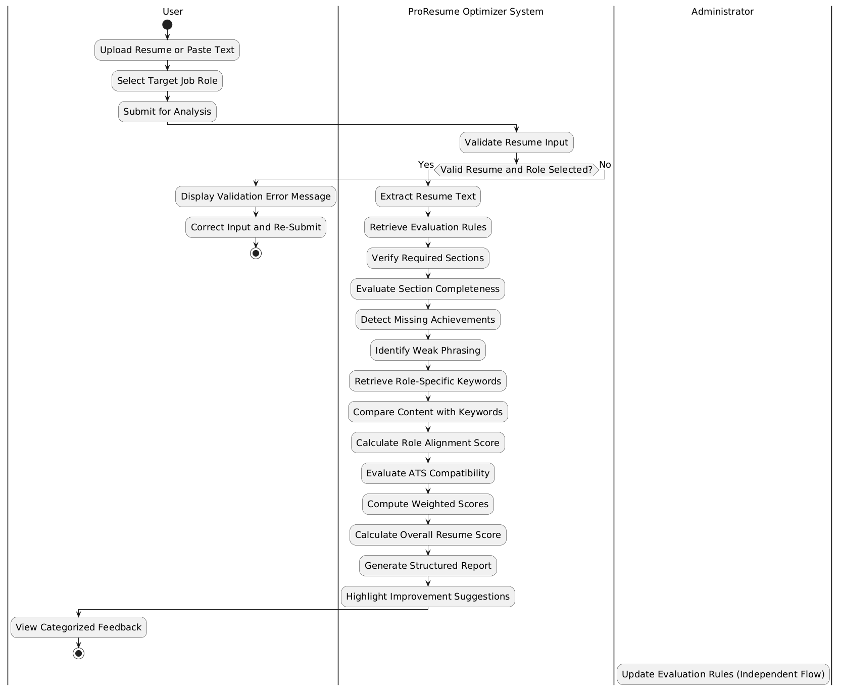
Figure 2. Activity Diagram – Resume Evaluation Workflow
Once the input is valid, the system proceeds with processing in a structured sequence. The resume text is extracted and evaluation rules are retrieved. The system verifies required sections, evaluates section completeness, detects missing achievements, and identifies weak phrasing. It then retrieves role-specific keywords and compares them with the resume content to calculate a role alignment score.
Following this, the system evaluates ATS compatibility, computes weighted scores for each evaluation category, and calculates the overall resume quality score. A structured report is generated, and improvement suggestions are highlighted within the resume content. Finally, the results are presented to the user as categorized feedback.
The diagram also includes an Administrator lane, where evaluation rules can be updated independently. This process does not interrupt the main workflow but supports system adaptability.

Structural Model
The Structural Model describes the internal organization of the system by defining its components, their attributes, and the relationships between them. It represents the to-be system, showing how the ProResume Optimizer is designed to function after implementation. This model focuses on system structure rather than behavior and provides a blueprint for how data and processing responsibilities are distributed across classes and objects (Dennis et al., 2020).

Class Diagram
The class diagram presents the static structure of the ProResume Optimizer system and illustrates how system components are organized and interconnected.
At the top level, the system includes two interface classes:
- UserInterface, which manages user interactions such as uploading resumes, selecting job roles, and displaying evaluation reports
- AdminInterface, which allows administrators to configure scoring weights, keyword libraries, and validation rules
The central component of the system is the ResumeEvaluationController, which coordinates the entire evaluation workflow. It maintains references to the selected JobRole and the active EvaluationRuleSet, and it is responsible for validating input, extracting resume data, invoking analyzers, and generating the final evaluation report.
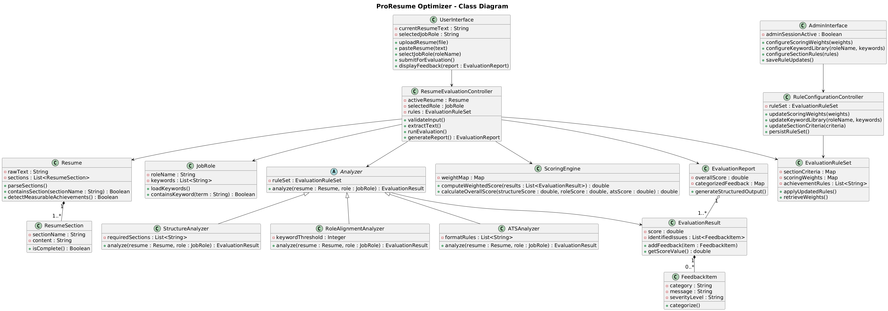
Figure 3. Class Diagram – ProResume Optimizer System
The system represents resume data through the Resume class, which stores the raw text and organizes it into multiple ResumeSection objects. Each ResumeSection contains attributes such as section name, content, and a flag indicating whether the section is complete. This structure allows the system to evaluate different parts of the resume independently. The JobRole class complements this by storing role-specific information, including relevant keywords and lookup functionality used during analysis.
Evaluation logic is implemented through a set of analyzer classes that follow a consistent structure. A general Analyzer abstraction defines the evaluation interface, while specialized classes such as StructureAnalyzer, RoleAlignmentAnalyzer, and ATSAnalyzer perform targeted analysis. The StructureAnalyzer verifies required sections and evaluates completeness, the RoleAlignmentAnalyzer compares resume content against role-specific keywords using a defined threshold, and the ATSAnalyzer evaluates formatting and keyword-related criteria associated with automated screening systems.
Each analyzer produces an EvaluationResult, which includes a computed score, identified issues, and associated feedback. These results are passed to the ScoringEngine, which applies a weighted scoring model to combine outputs from different analyzers. The scoring process results in both category-level scores and an overall resume quality score.
The final output is managed by the EvaluationReport class, which organizes evaluation results into a structured format suitable for presentation. It includes the overall score as well as categorized feedback. The EvaluationRuleSet supports this process by defining configurable parameters such as section validation criteria, scoring weights, and keyword libraries. Administrative updates to these rules are handled through the RuleConfigurationController, ensuring that evaluation logic can be modified without affecting the core processing flow. Individual feedback elements are represented using the FeedbackItem class, which stores messages along with their category and severity level.
The relationships shown in the diagram reflect a layered structure in which the controller coordinates data objects and analyzers, analyzers rely on rule definitions, and results are aggregated into a report. This design ensures modularity, maintainability, and alignment between system structure and evaluation logic.

Object Diagram
The object diagram presents a runtime snapshot of the ProResume Optimizer system, showing how specific instances of classes interact during a resume evaluation process. It provides a concrete view of how the abstract structure defined in the class diagram is instantiated and used in execution.
The diagram begins with an active administrative session represented by an instance of the AdminInterface. This instance interacts with a RuleConfigurationController, which manages an EvaluationRuleSet containing predefined parameters such as section validation criteria, scoring weights, and achievement rules. These parameters are used by the system during evaluation.
On the user side, an instance of the UserInterface contains the submitted resume text and the selected job role. This information is passed to an instance of the ResumeEvaluationController, which manages the evaluation process. The controller references a Resume object representing the input document and a JobRole object that contains role-specific keywords relevant to the selected position.
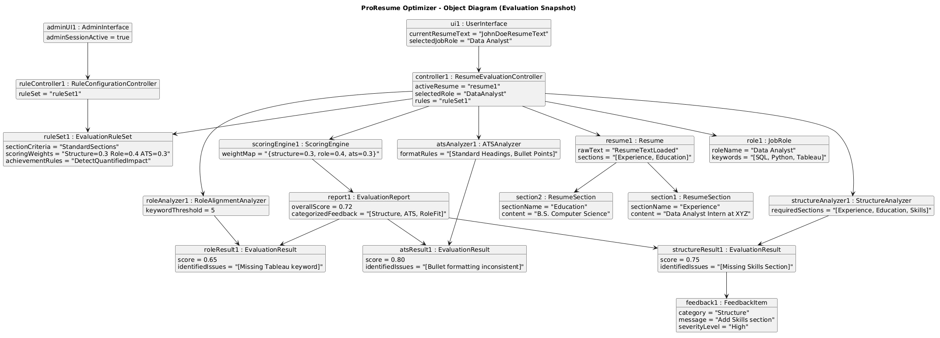
Figure 4. Object Diagram – Resume Evaluation Snapshot
The Resume object is composed of multiple ResumeSection instances, such as experience and education, each containing specific content extracted from the resume. These section objects are used by the evaluation components to perform targeted analysis.
The controller invokes analyzer instances, including StructureAnalyzer, RoleAlignmentAnalyzer, and ATSAnalyzer. Each analyzer evaluates the resume based on its respective criteria and produces an EvaluationResult. These results include scores and identified issues, such as missing keywords or incomplete sections.
The EvaluationResult objects are then passed to a ScoringEngine instance, which applies predefined weights to compute an overall score. The computed results are used to generate an EvaluationReport instance, which contains the overall score and categorized feedback. Individual feedback elements are represented as FeedbackItem instances, each capturing a specific suggestion or issue identified during evaluation.
The diagram demonstrates how system components collaborate during execution, showing the flow from user input through analysis and scoring to final report generation. It also highlights how administrative configurations influence the evaluation process without interfering with the main execution flow.

Behavioral Model
The Behavioral Model describes how system components interact during execution to perform specific operations. It focuses on the dynamic behavior of the system by capturing the sequence of interactions between objects over time. This model complements the structural view by showing how control flows through the system when a user initiates a resume evaluation (Dennis et al., 2020).

Sequence Diagram
The sequence diagram illustrates how the ProResume Optimizer system processes a resume from submission to feedback generation. It captures the interaction between the user interface, control logic, evaluation components, and supporting modules in a time-ordered sequence.
The interaction begins when the user submits resume content along with a selected job role through the UserInterface. This request is forwarded to the ResumeEvaluationController, which acts as the central coordinator for the evaluation process. The controller first validates the input to ensure that both the resume content and job role are available. If validation fails, control is returned to the interface with an appropriate error response.
Once the input is validated, the controller initiates resume processing by extracting the text and organizing it into structured sections. It then retrieves the applicable evaluation rules from the EvaluationRuleSet, including scoring weights, required sections, and keyword libraries associated with the selected job role.
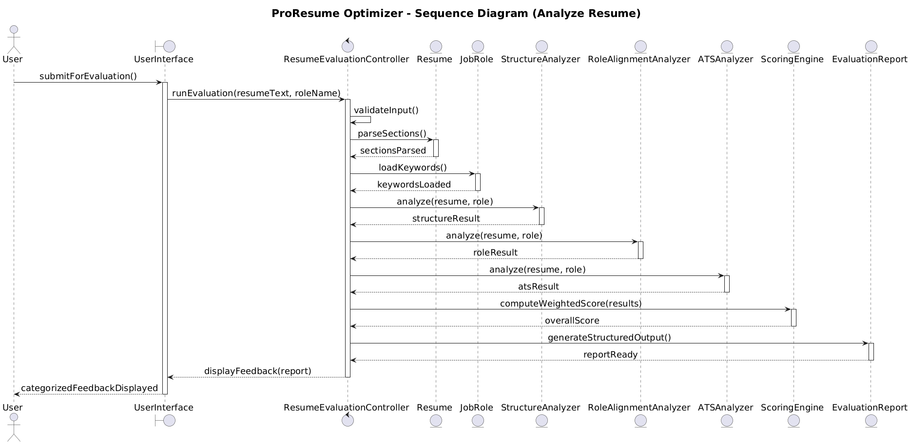Figure 5. Sequence Diagram – Resume Evaluation Process.
The controller proceeds by invoking the analyzer components in sequence. The StructureAnalyzer evaluates the presence and completeness of required sections and identifies missing elements or weak phrasing. The RoleAlignmentAnalyzer compares the resume content with role-specific keywords and determines the degree of alignment. The ATSAnalyzer evaluates formatting consistency and keyword usage to assess compatibility with automated screening systems.
Each analyzer returns an EvaluationResult containing a score and identified issues. These results are passed back to the ResumeEvaluationController, which forwards them to the ScoringEngine. The scoring engine applies predefined weights to compute category-level scores and an overall resume quality score.
After scoring is completed, the controller creates an EvaluationReport, which organizes the results into structured feedback categories. The report includes the overall score along with detailed suggestions for improvement. The controller then returns this report to the UserInterface, where the results are displayed to the user in a categorized and readable format.
The sequence diagram highlights the central role of the controller in coordinating all interactions, the modular execution of analyzers, and the aggregation of results into a final report. It also reflects how evaluation rules influence processing without directly interrupting the flow of execution.

Design Model
The Design Model refines the structural and behavioral models into implementation-level detail. It defines how system components are organized into logical groupings and how responsibilities are distributed at the class and method level. This section focuses on translating the conceptual design into a structure that supports maintainability, modularity, and clear separation of concerns (Dennis et al., 2020).

Package Diagram
The package diagram illustrates the logical organization of the ProResume Optimizer system by grouping related classes into five layers: Interface, Controller, Analysis, Model, Evaluation, and Configuration. This layered structure separates responsibilities and controls interactions between system components. The Interface Layer contains UserInterface and AdminInterface, which handle resume submission, role selection, and administrative configuration tasks. These components communicate with the Controller Layer, which includes ResumeEvaluationController and RuleConfigurationController. The controllers coordinate the evaluation workflow, manage analyzer execution, and apply evaluation rules.
The Analysis Layer contains the abstract Analyzer class and its specialized implementations: StructureAnalyzer, RoleAlignmentAnalyzer, and ATSAnalyzer. These components perform resume evaluation using data from the Model Layer and rules from the Configuration Layer. The Model Layer includes core entities such as Resume, ResumeSection, and JobRole, which store resume content and role-specific information. The Configuration Layer contains EvaluationRuleSet, which manages evaluation criteria, keyword mappings, and scoring rules. The Evaluation Layer aggregates analysis results through components such as EvaluationResult, ScoringEngine, EvaluationReport, and FeedbackItem. These classes compute final scores and organize feedback into structured reports for the user.
The dependency flow follows a controlled layered architecture where interface components interact with controllers, controllers coordinate analyzers and model access, and evaluation components generate final outputs. This organization improves modularity, maintainability, and separation of concerns within the system.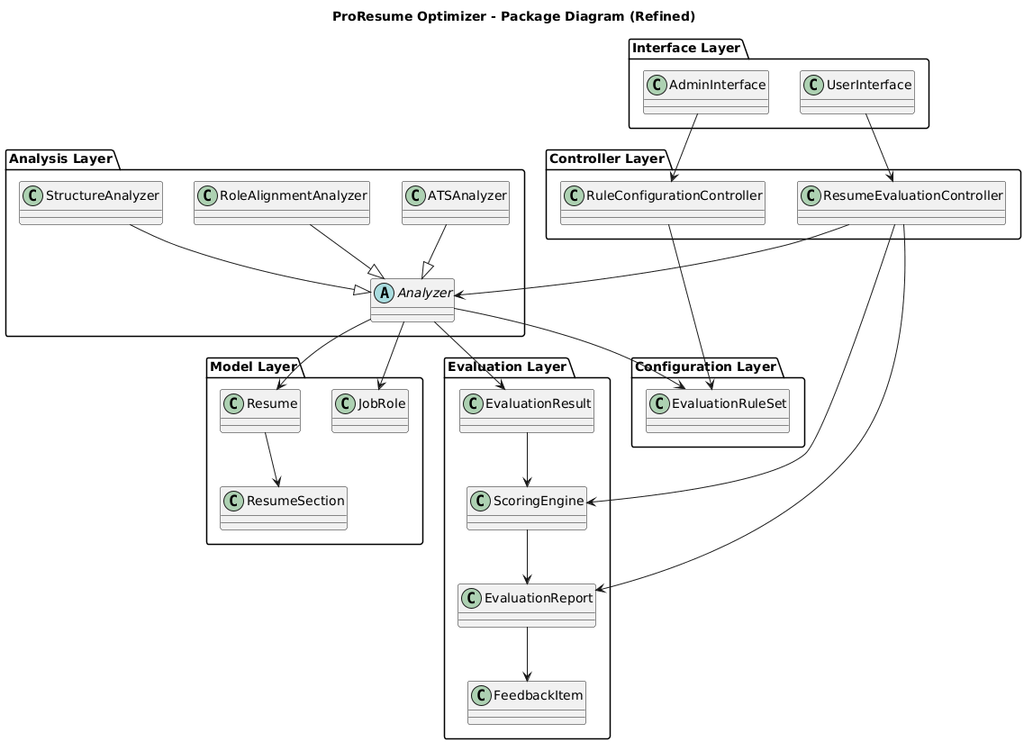
Figure 6. Package Diagram – ProResume Optimizer System

Contract (Operation Specification)
The contract defines the expected behavior of a major system operation by specifying its inputs, outputs, preconditions, and postconditions. In the ProResume Optimizer system, the primary operation is handled by the ResumeEvaluationController, which coordinates the resume evaluation workflow (Dennis et al., 2020).
Operation Name: evaluate(resume_text, role)
Description: This operation evaluates resume content using structure analysis, role alignment analysis, ATS evaluation, weak phrasing detection, and weighted score computation. It generates a structured evaluation report containing feedback and missing keywords.
Input Parameters: resume_text : String — Resume content provided by the user, role : String — Selected target job role
Output: EvaluationReport — Contains final score, structure feedback, missing keywords, and weak phrasing results
Preconditions: Resume text must be provided, A valid target role must exist in the role keyword library, Analyzer and scoring components must be initialized
Postconditions: Resume text is converted into a Resume object, Resume sections are extracted and analyzed, Role keyword matching is completed, ATS keyword analysis is performed, Weak phrasing is identified, Final weighted score is computed, An EvaluationReport object is generated and returned
Processing Summary: The operation creates a Resume object from the input text, executes structure, role alignment, and ATS analyzers, detects weak phrasing, computes a final score using the scoring engine, and generates a structured evaluation report.

Method Specification
The method specification describes the behavior of a selected method within the system. In this project, the evaluate() method of the ResumeEvaluationController coordinates the complete resume evaluation process (Dennis et al., 2020).
Class: ResumeEvaluationController
Method Name: evaluate(resume_text, role)
Description: This method performs resume evaluation by applying structure analysis, role keyword matching, ATS analysis, weak phrasing detection, and weighted score calculation.
Input Parameters: resume_text : String — Resume content submitted by the user, role: String — Selected target job role
Return Value: EvaluationReport — Contains final score and evaluation feedback
Preconditions: Resume text must not be empty, Target role must exist in the keyword dictionary, Analyzer components and scoring engine must be initialized
Postconditions: Resume sections are extracted, Missing sections are identified, Role-specific keywords are evaluated, ATS compatibility is analyzed, Weak phrasing is detected, Final score is computed, Evaluation report is returned
Error Handling: Empty resume text reduces evaluation quality, Missing role definitions prevent accurate role alignment analysis
Design Considerations: The controller centralizes execution of the evaluation workflow, Analyzer components operate independently for modularity, Scoring logic is separated from analysis logic, Feedback generation remains structured and interpretable.

Data Management Layer Design
The Data Management Layer Design defines how system data is represented, stored, and accessed during execution. It focuses on how objects are handled within the system and how data persistence is managed. For the ProResume Optimizer system, the design emphasizes lightweight processing and avoids long-term storage, as resume evaluation is performed dynamically based on user input (Dennis et al., 2020).

Object Persistence Format
The ProResume Optimizer system does not rely on permanent data storage. Instead, it follows an in-memory object persistence approach, where all data objects are created, processed, and discarded within the execution cycle of a single evaluation request. This design aligns with the system’s purpose as an evaluation tool rather than a data management system.
When a user submits resume content, the system creates a Resume object that holds the raw text and derived structured sections. These sections are represented as ResumeSection objects, each containing attributes such as section name, content, and completeness status. This object-based structure allows analyzers to access and evaluate different parts of the resume independently.
During evaluation, additional objects are instantiated to support processing. Analyzer classes produce EvaluationResult objects, which store intermediate scores and identified issues. These results are then passed to the ScoringEngine, which computes the final score using predefined weights. The final output is encapsulated in an EvaluationReport object, which contains the overall score and categorized feedback.
Configuration data, such as keyword libraries and scoring weights, is maintained in the EvaluationRuleSet. This object is loaded at runtime and used by analyzers and the scoring engine. Although configurable, it is not persistently stored within the system’s current scope and is assumed to be predefined or initialized during system setup.
The system processes all objects within a single execution flow. Once the evaluation is complete and the report is returned to the user, these objects are no longer retained. This approach ensures that sensitive user data, such as resume content, is not stored beyond the evaluation session.
- The object persistence format is therefore characterized by:
- Temporary, in-memory object creation
- Structured object relationships for evaluation processing
- No reliance on external databases or file-based storage
- Automatic disposal of data after execution
This design supports privacy, reduces system complexity, and aligns with the intended use of the system as a real-time evaluation tool rather than a persistent data system.

Database Schema
The ProResume Optimizer system does not implement a traditional database schema. Instead, it uses an in-memory data representation model, where all data is structured using Python objects and dictionaries during runtime. This approach is consistent with the system’s design, which focuses on real-time evaluation rather than persistent storage.
The primary data structure begins with the resume input, which is provided as raw text. This input is converted into a Resume object, where the text is preprocessed and divided into sections such as experience, education, and skills. These sections are stored internally as a dictionary, where each section name acts as a key and its corresponding content is the value. This replaces the need for a separate table-based structure.
Role-related data is also maintained in memory using a dictionary called role_keywords. This structure maps each job role to a list of associated keywords. For example, the role “Data Analyst” is linked to keywords such as Python, SQL, and statistics. This dictionary functions as a lightweight substitute for a relational table like RoleKeywords.
During evaluation, intermediate results are not stored in separate entities or tables. Instead, values such as structure score, role alignment score, ATS score, and identified issues are stored as variables within the execution of the evaluate() method. These values are passed between components such as StructureAnalyzer, RoleAlignmentAnalyzer, and ATSAnalyzer.
The final output is encapsulated in the EvaluationReport object, which contains the computed score, structural feedback, missing keywords, and weak phrasing results. This object acts as the final structured representation of evaluation results and replaces the need for persistent result storage.
The system therefore follows a non-persistent schema design, where:
- Resume data is stored as object attributes and dictionaries
- Role and keyword mappings are maintained using in-memory dictionaries
- Intermediate evaluation data is handled through method-level variables
- Final results are encapsulated in a single output object
This design eliminates the need for database tables, reduces system complexity, and ensures that user data is not retained beyond the evaluation session. It also aligns with the system’s role as a processing and feedback tool rather than a data storage system.

Human–Computer Interaction Layer Design
The Human–Computer Interaction (HCI) layer defines how users interact with the ProResume Optimizer system and how results are presented. The design follows a simple, single-screen interaction flow to reduce effort and keep the evaluation process clear. Users provide resume content, select a target role, and receive structured feedback without navigating across multiple pages.

Wireframe Design
The interface is organized into three primary sections: Input Panel, Action Area, and Output Panel. At the top of the interface, a header displays the system title, ProResume Optimizer, to provide context. Below the header, the Input Panel allows the user to enter resume content and select a target job role. The resume input is presented as a large text area to support both pasted text and edited content. Adjacent to this field, a dropdown menu enables role selection (e.g., Data Analyst, Project Manager). This reflects the system requirement that a role must be selected before evaluation.
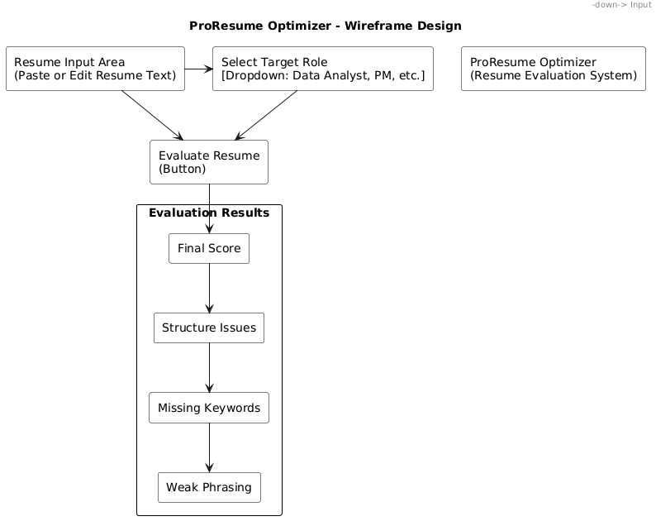
Figure 7. Wireframe Design – ProResume Optimizer Interface
The Action Area contains a single primary control, the Evaluate Resume button. This button triggers the evaluation process handled by the controller. The placement is central and visually distinct to guide the user toward the main action.
The Output Panel occupies the lower portion of the interface and displays the evaluation results. The results are grouped into clearly labeled sections, including:
- Final Score
- Structure Issues
- Missing Keywords
- Weak Phrasing
Each section is presented in a readable format, allowing users to quickly identify areas for improvement. The output panel updates dynamically after evaluation and supports re-submission by allowing users to modify the input and run the evaluation again.
The interaction flow is linear: input → evaluation → feedback. This minimizes cognitive load and supports repeated use without requiring additional navigation or configuration steps.

Physical Architecture Layer Design
The Physical Architecture Layer describes how the ProResume Optimizer system is executed within its runtime environment. The system is implemented as a standalone Python application running locally in a Jupyter Notebook environment. Since the implementation focuses on resume text processing and rule-based analysis, the architecture remains lightweight and does not require external servers, databases, or distributed infrastructure.

Hardware and Software Specification
The system is designed to operate on a standard personal computer without specialized hardware requirements. A machine with an Intel i3 processor or equivalent, at least 4 GB RAM, and standard storage capacity is sufficient for execution. Since the system performs lightweight text analysis operations, no GPU or high-performance computing resources are required.
The implementation is developed in Python and executed through Jupyter Notebook. The system relies on standard Python libraries such as re for text processing and numpy for numerical operations. All components, including analyzers, controllers, and scoring logic, execute within a single local runtime environment. No database systems, cloud services, or external APIs are used in the current implementation.

Operational Requirements
The system is designed for interactive single-user execution. A user provides resume content, selects a target role, and receives evaluation feedback during the same execution session. The system requires valid resume text and an available role keyword mapping before evaluation can begin.

All processing is performed in memory, meaning that resume data is analyzed only during execution and is not permanently stored. The system supports repeated evaluations within the same notebook session without requiring reinitialization. Administrative configuration, such as updating role-specific keyword mappings, is handled directly within the source code through the role_keywords dictionary.

Performance Requirements
The system is expected to process a standard resume within 1–3 seconds under normal execution conditions. Operations such as section extraction, keyword matching, ATS evaluation, weak phrasing detection, and score computation are lightweight text-processing tasks and require minimal computational resources.
Memory usage is expected to remain below 200 MB during execution because the system processes only small text inputs and stores temporary objects in memory. The system should support multiple sequential evaluations within the same session without noticeable degradation in response time.
The current implementation is intended for single-user execution and is not designed for concurrent multi-user workloads. However, the modular architecture allows future extension into a larger application or web-based deployment if required (Dennis et al., 2020).

Construction
This section describes how the ProResume Optimizer system is implemented and validated. The implementation follows a modular object-oriented structure where resume processing, analysis, scoring, and report generation are separated into independent components. The system is developed in Python within a Jupyter Notebook environment, allowing step-by-step execution and direct observation of outputs. The design emphasizes readability, traceability, and clear mapping between the system models and the implemented code (Dennis et al., 2020).
The implementation is organized into logical components including resume preprocessing, section extraction, analyzer modules, scoring logic, controller coordination, and evaluation reporting. Each component performs a specific responsibility within the evaluation workflow. The controller class coordinates the execution of analyzers and combines their results into a final evaluation report. This modular structure improves maintainability and allows individual components to be modified independently without affecting the overall system behavior.

Unit Test Description
This section describes how unit testing is used to validate the behavior of individual components in the system. Testing is performed using simple Python test functions executed within the notebook environment rather than a formal testing framework. This approach is consistent with the lightweight and demonstration-oriented nature of the implementation.

The Resume class is tested to verify that preprocessing and section extraction operate correctly. Test cases confirm that resume text is converted into lowercase format and that sections such as experience, education, and skills are identified properly.
The analyzer classes are tested independently to validate their evaluation logic. The StructureAnalyzer is tested to ensure that missing sections and measurable achievements are correctly identified. The RoleAlignmentAnalyzer is tested using predefined role keyword mappings to verify keyword matching and missing keyword detection. The ATSAnalyzer is tested to confirm that ATS keyword scoring behaves as expected.
Additional tests validate weak phrasing detection and weighted score computation. The ScoringEngine is tested using predefined input values to ensure that final scores are calculated consistently using the implemented formula.
The ResumeEvaluationController is tested as the central coordination component of the system. Test cases simulate complete evaluation runs using sample resume text and target roles. The results are verified to ensure that evaluation reports are generated correctly and contain scores, feedback, and keyword analysis results.
Testing is performed directly within notebook cells, allowing immediate observation of outputs and validation of system behavior. This approach ensures that individual modules and the complete evaluation workflow operate consistently and produce reliable results.

Integration Test
Formal integration testing is not implemented in this project. Instead, integration behavior is validated through complete execution of the evaluation workflow within the notebook environment. The controller coordinates interactions between preprocessing, analyzers, scoring, and report generation, allowing the full pipeline to be tested during execution.
This end-to-end execution confirms that resume input flows correctly across all system components and that the final evaluation report is generated successfully. Since the system operates entirely within a single runtime environment and does not involve external services or databases, this approach provides sufficient validation for the current project scope.

Build and Run Instructions
This section describes how to execute the ProResume Optimizer system using the provided notebook file. The system is implemented in Python and runs locally in a Jupyter Notebook environment.
To run the project, ensure that Python 3.x and Jupyter Notebook are installed on the system. Install the required dependency using the following command:
pip install numpy
The implementation mainly relies on built-in Python libraries such as re, along with numpy for numerical operations.
After installation, open the notebook file (ProResumeOptimizer_Resume_Evaluationand_Improvement_System.ipynb) in Jupyter Notebook or JupyterLab and execute the cells sequentially from top to bottom. The notebook will process the resume input, perform structure, role alignment, and ATS analysis, compute the final evaluation score, generate the evaluation report, and execute the unit tests. All outputs are displayed directly within the notebook environment.

Acknowledgements
The development of the ProResume Optimizer system was supported by the guidance and structure provided through the course Systems Analysis and Design. The concepts of object-oriented design, UML modeling, and system structuring applied in this project are based on the framework presented by Dennis, Wixom, and Tegarden (2020).
Additional conceptual understanding of resume construction and evaluation practices was informed by professional resources on resume writing and Applicant Tracking Systems, including Doyle (2020) and Herbert (2024). These sources provided context for defining evaluation criteria such as structure, keyword relevance, and ATS compatibility.
The project was completed as part of an academic exercise, with the goal of applying system design principles to a practical problem in career development.

Conclusions
The ProResume Optimizer system demonstrates how a modular, rule-based design can be applied to resume evaluation and feedback generation. The system was developed to address common resume-related issues such as missing sections, weak phrasing, lack of measurable achievements, and insufficient alignment with target job roles. By combining structure analysis, role-specific keyword matching, ATS evaluation, and weighted scoring, the system provides interpretable feedback that helps users identify areas for improvement.
The implementation follows a modular object-oriented architecture in which preprocessing, analysis, scoring, and report generation are separated into independent components. This structure improves readability, maintainability, and alignment between the UML models and the implemented code. The use of lightweight processing techniques and in-memory execution keeps the system simple while still supporting complete resume evaluation workflows.
The system satisfies the primary functional requirements by allowing users to submit resume content, perform repeated evaluations, and receive structured feedback within a single execution session. Since the evaluation logic is based on predefined rules and keyword matching, the system remains transparent and easy to interpret. However, this rule-based approach also limits adaptability when compared with machine learning or data-driven evaluation systems.
Future improvements may include expanding the keyword libraries, enhancing scoring logic, supporting file uploads, and integrating a graphical or web-based interface. Due to the modular design of the system, these enhancements can be incorporated without major changes to the existing architecture (Dennis et al., 2020).

References
Dennis, A., Wixom, B., & Tegarden, D. (2020). Systems analysis and design: An object-oriented approach with UML (6th ed.). Wiley.
Doyle, A. (2020). The complete guide to writing professional resumes. Career Press.
Herbert, M. (2024). How to make an ATS-friendly resume: Tips for ATS 2025. TopResume. https://topresume.com/career-advice/what-is-an-ats-resume

Source Code with Unit Tests
This section presents the complete implementation of the ProResume Optimizer system along with representative unit tests. The code reflects the modular design described in earlier sections and demonstrates how resume evaluation is performed using rule-based analyzers.

Core System Implementation
#!/usr/bin/env python
# coding: utf-8

# Import Libraries
import re
import numpy as np

# Sample Resume Input (Simulating User Upload)
simulated_resume_text = """
John Doe

Experience:
Worked on data analysis projects using Python.
Improved system efficiency.

Education:
Bachelor of Science in Computer Science

Skills:
Python, SQL, Machine Learning
"""

# Select Target Job Role (UC-1)
target_role = "Data Analyst"

# Define Role-Based Keyword Library (Admin Logic)
role_keywords = {
"Data Analyst": ["python", "sql", "data", "analysis", "visualization", "statistics"],
"Project Manager": ["planning", "coordination", "stakeholder", "timeline", "budget"]
}

# Resume Class (Core Data Object)
class Resume:
def __init__(self, text):
self.raw_text = text
self.cleaned_text = self.preprocess(text)
self.sections = self.extract_sections()

def preprocess(self, text):
return text.lower()

def extract_sections(self):
sections = {
"experience": "",
"education": "",
"skills": ""
}

for key in sections:
pattern = key + r":(.*?)(\n\n|$)"
match = re.search(pattern, self.cleaned_text, re.DOTALL)
if match:
sections[key] = match.group(1).strip()

return sections

# StructureAnalyzer (UC-4, UC-8)
class StructureAnalyzer:
def evaluate(self, resume):
score = 0
feedback = []

for section, content in resume.sections.items():
if content:
score += 1
else:
feedback.append(f"Missing {section} section")

# Check measurable achievements
numbers = re.findall(r'\d+', resume.cleaned_text)
if not numbers:
feedback.append("No measurable achievements found")

return score, feedback

# RoleAlignmentAnalyzer (UC-6)
class RoleAlignmentAnalyzer:
def __init__(self, role_keywords):
self.role_keywords = role_keywords

def evaluate(self, resume, role):
keywords = self.role_keywords.get(role, [])

matches = [kw for kw in keywords if kw in resume.cleaned_text]
missing = [kw for kw in keywords if kw not in resume.cleaned_text]

score = len(matches) / len(keywords) if keywords else 0

return score, matches, missing

# ATSAnalyzer (UC-5)
class ATSAnalyzer:
def evaluate(self, resume, role_keywords, role):
keywords = role_keywords.get(role, [])

present = [kw for kw in keywords if kw in resume.cleaned_text]
missing = [kw for kw in keywords if kw not in resume.cleaned_text]

score = len(present)

return score, missing

# Weak Phrasing Detection
def detect_weak_phrasing(text):
weak_words = ["worked on", "responsible for", "helped"]
found = [word for word in weak_words if word in text]
return found

# ScoringEngine (UC-7)
class ScoringEngine:
def compute(self, structure_score, role_score, ats_score):
final_score = (structure_score * 20) + (role_score * 40) + (ats_score * 10)
return final_score

# EvaluationReport (UC-7, UC-9)
class EvaluationReport:
def __init__(self, score, structure_feedback, missing_keywords, weak_phrases):
self.score = score
self.structure_feedback = structure_feedback
self.missing_keywords = missing_keywords
self.weak_phrases = weak_phrases

def display(self):
print("----- Resume Evaluation Report -----")
print(f"Final Score: {self.score}")
print(f"Structure Issues: {self.structure_feedback}")
print(f"Missing Keywords: {self.missing_keywords}")
print(f"Weak Phrasing: {self.weak_phrases}")

# ResumeEvaluationController
class ResumeEvaluationController:
def __init__(self, role_keywords):
self.structure_analyzer = StructureAnalyzer()
self.role_analyzer = RoleAlignmentAnalyzer(role_keywords)
self.ats_analyzer = ATSAnalyzer()
self.scoring_engine = ScoringEngine()
self.role_keywords = role_keywords

def evaluate(self, resume_text, role):
resume = Resume(resume_text)

# Structure Analysis
structure_score, structure_feedback = self.structure_analyzer.evaluate(resume)

# Role Alignment
role_score, matches, missing_keywords = self.role_analyzer.evaluate(resume, role)

# ATS Analysis
ats_score, ats_missing = self.ats_analyzer.evaluate(resume, self.role_keywords, role)

# Weak phrasing
weak_phrases = detect_weak_phrasing(resume.cleaned_text)

# Final scoring
final_score = self.scoring_engine.compute(
structure_score,
role_score,
ats_score
)

# Report
report = EvaluationReport(
final_score,
structure_feedback,
missing_keywords,
weak_phrases
)

return report

# Run
controller = ResumeEvaluationController(role_keywords)

report = controller.evaluate(simulated_resume_text, target_role)

report.display()

# Re-Submission
updated_resume = simulated_resume_text + "\nImproved efficiency by 30%"

report = controller.evaluate(updated_resume, target_role)

report.display()

Unit Tests
### Unit Test
def test_structure_analyzer():
resume_text = "Experience in Python. Education in Computer Science."
resume = Resume(resume_text)

analyzer = StructureAnalyzer()
score, missing = analyzer.evaluate(resume)

assert score < 1
assert "skills" in missing

def test_role_alignment():
resume_text = "Experienced in Python and SQL"
resume = Resume(resume_text)

analyzer = RoleAlignmentAnalyzer()
role_keywords = ["python", "sql", "tableau"]

score, matches, missing = analyzer.evaluate(resume, role_keywords)

assert "python" in matches
assert "tableau" in missing

def test_scoring_engine():
scoring = ScoringEngine()
final_score = scoring.compute(0.8, 0.6, 0.7)

assert round(final_score, 2) == 0.68

def test_controller_evaluate():
controller = ResumeEvaluationController()

resume_text = "Experience in Python and SQL. Education in Data Science."
role_keywords = ["python", "sql", "tableau"]

report = controller.evaluate(resume_text, role_keywords)

assert report is not None
assert report.final_score >= 0

Generated Code Documentation
This section describes how code-level documentation is provided in the ProResume Optimizer system based on the actual implementation. Since the system is implemented in Python, formal JavaDoc-style documentation is not used. Instead, the notebook follows a structured documentation approach using section headers, inline comments, and clearly organized class definitions.
The implementation is divided into logical sections such as resume preprocessing, analyzer modules, scoring logic, report generation, controller coordination, and unit testing. Each section is introduced using descriptive headers that explain the purpose of the corresponding implementation block. This organization allows the evaluation workflow to be followed step by step from resume input to final report generation.
The Resume class contains methods for preprocessing text and extracting sections such as experience, education, and skills using regular expression matching. The implementation includes comments describing how resume text is cleaned and how sections are identified from the input content.
The analyzer components are documented through structured class definitions and inline explanations. The StructureAnalyzer evaluates section completeness and measurable achievements, the RoleAlignmentAnalyzer compares resume content against role-specific keywords, and the ATSAnalyzer evaluates keyword presence for ATS compatibility. The logic inside each analyzer is separated clearly so that the responsibilities of each component remain understandable and traceable.
The ScoringEngine class documents the weighted score computation process, while the EvaluationReport class organizes the final output and provides a display method for presenting feedback results. The ResumeEvaluationController acts as the central coordination component and includes comments describing each stage of the evaluation workflow, including structure analysis, role alignment, ATS evaluation, weak phrasing detection, and report generation.
Inline comments are also used throughout the implementation to explain important processing steps such as keyword matching, measurable achievement detection, and weak phrasing identification. This documentation approach improves readability and ensures that the relationship between the system design and implementation remains clear.

Class to Code Mapping
This section maps the classes defined in the structural model to their corresponding implementation in the ProResume Optimizer system. The mapping ensures traceability between the UML design and the actual Python implementation.
Class | Implementation in Code (Class / Function) | Description
Resume | Resume | Represents and preprocesses resume content while extracting sections
ResumeSection | Resume.extract_sections | Handles extraction of resume sections using regular expressions
JobRole | target_role / role_keywords | Represents the selected target job role and associated keywords
Analyzer | StructureAnalyzer / RoleAlignmentAnalyzer / ATSAnalyzer | Abstract analysis concept implemented through analyzer classes
StructureAnalyzer | StructureAnalyzer | Evaluates resume structure and section completeness
RoleAlignmentAnalyzer | RoleAlignmentAnalyzer | Checks alignment between resume content and role-specific keywords
ATSAnalyzer | ATSAnalyzer | Evaluates ATS keyword compatibility
ScoringEngine | ScoringEngine | Computes final weighted evaluation score
EvaluationResult | EvaluationReport | Stores evaluation outcomes and feedback
EvaluationReport | EvaluationReport | Generates and displays final evaluation feedback
FeedbackItem | structure_feedback / missing_keywords / weak_phrases | Represents feedback generated during evaluation
ResumeEvaluationController | ResumeEvaluationController | Coordinates the complete evaluation workflow
RuleConfigurationController | role_keywords dictionary | Stores configurable role-based keyword mappings
EvaluationRuleSet | role_keywords dictionary | Represents evaluation rules and keyword sets
UserInterface | Notebook execution cells | Represents user interaction through notebook input and execution
AdminInterface | Not Implemented | Administrative interface is not implemented in the current system

User Requirements to Code Mapping
This section maps the functional requirements of the ProResume Optimizer system to the corresponding implementation components in the code. The mapping provides traceability between user requirements and the methods or functions responsible for implementing them.
Requirement ID | Requirement Description | Class / Component | Method / Function
R1 | Submit resume content | ResumeEvaluationController | evaluate
R2 | Select target job role | target_role / role_keywords | Role selection variables
R3 | Preprocess resume text | Resume | preprocess
R4 | Extract resume sections | Resume | extract_sections
R5 | Validate resume structure | StructureAnalyzer | evaluate
R6 | Identify missing sections | StructureAnalyzer | evaluate
R7 | Detect measurable achievements | StructureAnalyzer | evaluate
R8 | Evaluate role alignment | RoleAlignmentAnalyzer | evaluate
R9 | Identify matching keywords | RoleAlignmentAnalyzer | evaluate
R10 | Identify missing keywords | RoleAlignmentAnalyzer | evaluate
R11 | Perform ATS evaluation | ATSAnalyzer | evaluate
R12 | Check ATS keyword presence | ATSAnalyzer | evaluate
R13 | Detect weak phrasing | detect_weak_phrasing | Function implementation
R14 | Compute final evaluation score | ScoringEngine | compute
R15 | Generate evaluation report | EvaluationReport | __init__
R16 | Display evaluation feedback | EvaluationReport | display
R17 | Coordinate evaluation workflow | ResumeEvaluationController | evaluate
R18 | Support repeated evaluations | ResumeEvaluationController | evaluate
R19 | Update resume and re-evaluate | Controller execution flow | Re-submission evaluation
R20 | Store role-specific keywords | role_keywords dictionary | Keyword configuration
R21 | Execute unit tests | Test functions | test_structure_analyzer / test_role_alignment / test_scoring_engine / test_controller_evaluate

Unimplemented User Requirement Explanations
This section explains the functional requirements that are not implemented or only partially supported in the current system implementation.
The ProResume Optimizer system is implemented as a lightweight prototype focused on rule-based resume evaluation within a Jupyter Notebook environment. As a result, some conceptual requirements shown in the design models are simplified or not fully implemented in code.
The system does not include a graphical user interface or standalone administrative interface. User interaction is performed directly through notebook inputs and predefined variables such as the simulated resume text and target role selection. Similarly, administrative configuration is limited to manual updates of the role_keywords dictionary within the source code.
Persistent storage and database integration are not implemented. All resume processing occurs in memory during execution, and evaluation results are not stored after the session ends. File upload functionality is also not included, since resume input is provided as plain text within the notebook.
The system uses rule-based evaluation logic rather than machine learning or adaptive scoring techniques. Keyword mappings and scoring weights are predefined and static. While this approach improves transparency and interpretability, it limits flexibility when handling varied resume formats or domain-specific terminology.
Formal integration testing and multi-user execution are not implemented. Validation is performed through direct execution of the evaluation workflow and lightweight unit test functions within the notebook environment.
These design choices were made to keep the implementation simple, modular, and aligned with the scope of the project while still satisfying the primary functional requirements of resume evaluation and feedback generation (Dennis et al., 2020).

